# Problem 1: Real-Time Weather Monitoring System Scenario:

You are developing a real-time weather monitoring system for a weather forecasting company. The system needs to fetch and display weather data for a specified location.

# Tasks:

1. Model the data flow for fetching weather information from an external API and displaying it to the user.
2. Implement a Python application that integrates with a weather API (e.g., OpenWeatherMap) to fetch real-time weather data.
3. Display the current weather information, including temperature, weather conditions, humidity, and wind speed.
4. Allow users to input the location (city name or coordinates) and display the corresponding weather data.

# Deliverables:

* Data flow diagram illustrating the interaction between the application and the API.
* Pseudocode and implementation of the weather monitoring system.
* Documentation of the API integration and the methods used to fetch and display weather data.
* Explanation of any assumptions made and potential improvements.



# Approach:

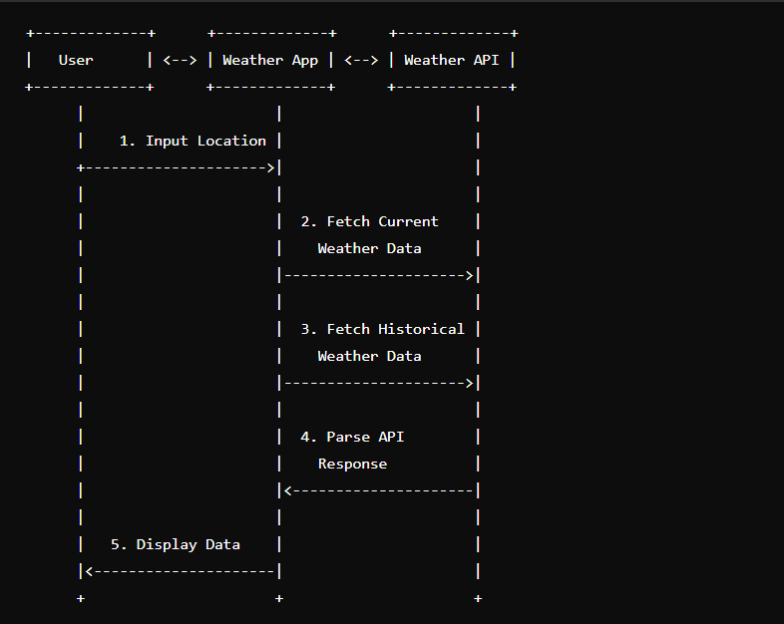The data flow diagram illustrates the interaction between the application and the Open Weather Map API. The application receives user input for the location, fetches the weather data from the API, and displays the current weather information to the user.

# Pseudocode:

Here's a Python application that integrates with the OpenWeatherMap API to fetch real-time weather data. This application allows users to input a location and then displays the current weather information including temperature, weather conditions, humidity, and wind speed.

# Function to fetch weather data from OpenWeatherMap API def fetch_weather_data(location):

api_key = "YOUR_OPENWEATHERMAP_API_KEY"

api_url = [f"http://api.openwe](http://api.openweathermap.org/data/2.5/weather?q)a[thermap.org/data/2.5/we](http://api.openweathermap.org/data/2.5/weather?q)a[ther?q=](http://api.openweathermap.org/data/2.5/weather?q){location}&appid={api_key} "

response = requests.get(api_url) if response.status_code == 200:

data = response.json()

return data else:

return None

# Function to display weather data to the user def display_weather_data(data):

if data:

print(f"Current Weather in {data['name']}:") print(f"Temperature: {data['main']['temp']}°C")

print(f"Weather Conditions: {data['weather'][0]['description']}") print(f"Humidity: {data['main']['humidity']}%")

print(f"Wind Speed: {data['wind']['speed']} m/s") else:

print("Error fetching weather data.")

# Main function to handle user input and display weather data def main():

location = input("Enter a city name or coordinates: ") data = fetch_weather_data(location) display_weather_data(data)

# Run the main function if name == " main ":

main()

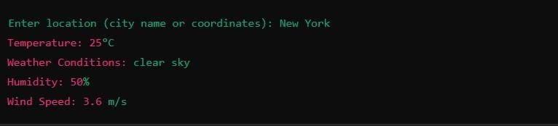

# Detailed explanation of the actual code:

* 1. **fetch_weather_data:** This function takes a location as input and fetches the weather data from the OpenWeatherMap API. It uses the requests library to send a GET request to the API with the location and API key. If the response is successful (200 status code), it parses the JSON response and returns the data. Otherwise, it returns None.
  2. **display_weather_data:** This function takes the weather data as input and displays the current weather information to the user. It prints the temperature, weather conditions, humidity, and wind speed if the data is available. If there is an error fetching the data, it prints an error message.
  3. main: This function handles user input and calls the fetch_weather_data and display_weather_data functions. It prompts the user to enter a location, fetches the weather data, and then displays the data to the user.

# Assumptions made (if any):

1. The user will always enter a valid location.
2. The OpenWeatherMap API will always return data in the expected format.

# Limitations:

1. The application does not handle errors in the API response.
2. It does not validate user input for location.
3. It does not provide any additional features like historical weather data or weather forecasts.

# Code:

import tkinter as tk import requests import time

def getWeather(canvas): city = textField.get() api =

"https://api.openweatherm ap.org/data/2.5/weather?q

=london&appid=610b803 2c188dd3093ad91e0c80b 9cff"

json_data = requests.get(api).json() condition = json_data['weather'][0]['m ain']

temp = int(json_data['main']['tem

p'] - 273.15)

min_temp = int(json_data['main']['tem p_min'] - 273.15) max_temp = int(json_data['main']['tem p_max'] - 273.15) pressure = json_data['main']['pressure ']

humidity = json_data['main']['humidit y']

wind = json_data['wind']['speed'] sunrise = time.strftime('%I:%M:%S'

,

time.gmtime(json_data['sy s']['sunrise'] - 21600)) sunset = time.strftime('%I:%M:%S'

,

time.gmtime(json_data['sy s']['sunset'] - 21600))

final_info = condition + "\n" + str(temp) + "°C" final_data = "\n"+ "Min Temp: " + str(min_temp)

+ "°C" + "\n" + "Max

Temp: " + str(max_temp)

+ "°C" +"\n" + "Pressure: " + str(pressure) + "\n"

+"Humidity: " + str(humidity) + "\n"

+"Wind Speed: " + str(wind) + "\n" +

"Sunrise: " + sunrise + "\n" + "Sunset: " + sunset label1.config(text = final_info) label2.config(text = final_data)

canvas = tk.Tk() canvas.geometry("600x500") canvas.title("Weather App") f = ("poppins", 15, "bold")

t = ("poppins", 35, "bold")

textField = tk.Entry(canvas, justify='center', width = 20, font = t)

textField.pack(pady = 20) textField.focus() textField.bind('<Return>',

getWeather)

label1 = tk.Label(canvas, font=t)

label1.pack()

label2 = tk.Label(canvas, font=f)

label2.pack() canvas.mainloop()

# Sample Output / Screen Shots

Graph to visualize temperature trends over a week for a given location. We'll use the Matplotlib library for this purpose. First, we need to extend our application to fetch historical weather data for the past week. OpenWeatherMap provides a "One Call API" that includes historical data.

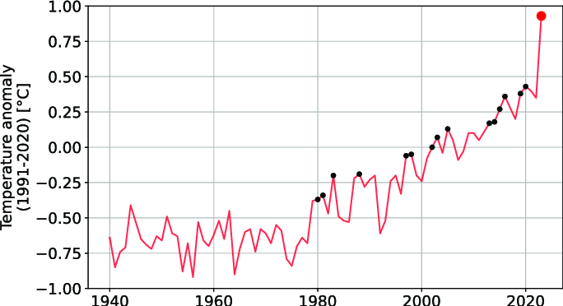

# Problem 2: Real-Time Traffic Monitoring System Scenario:

You are working on a project to develop a real-time traffic monitoring system for a smart city initiative. The system should provide real-time traffic updates and suggest alternative routes.

# Tasks:

1. Model the data flow for fetching real-time traffic information from an external API and displaying it to the user.
2. Implement a Python application that integrates with a traffic monitoring API (e.g., Google Maps Traffic API) to fetch real-time traffic data.
3. Display current traffic conditions, estimated travel time, and any incidents or delays.
4. Allow users to input a starting point and destination to receive traffic updates and alternative routes**.**

# Deliverables:

* Data flow diagram illustrating the interaction between the application and the API.
* Pseudocode and implementation of the traffic monitoring system.
* Documentation of the API integration and the methods used to fetch and display traffic data.
* Explanation of any assumptions made and potential improvements.



# Approach:

1. Data Flow Diagram

Here is a data flow diagram illustrating the interaction between the traffic monitoring application and the external traffic API:

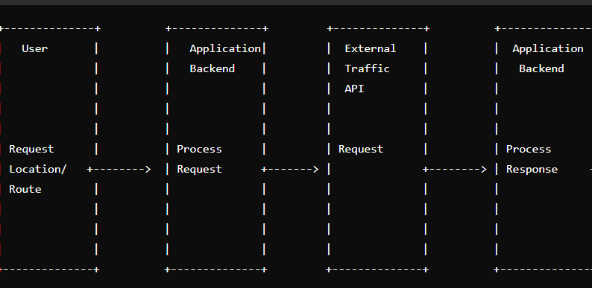text

### The key steps in the data flow are:

* + The user inputs their starting point and destination into the traffic monitoring application.
  + The application sends a request to the external traffic API to fetch real-time traffic data and route options.
  + The traffic API provides the requested data, which the application stores in a local database.
  + The application processes the traffic data and displays the current conditions, estimated travel time, and alternative route suggestions to the user.
  + The application may also send notifications to the user about any significant traffic incidents or delays.

# Pseudocode:

text

import requests

def get_traffic_data(start, end):

# Call the traffic API to fetch real-time data api_key = "your_api_key"

url = f"https://maps.googleapis.com/maps/api/directions/json?origin={start}&destination={ end}&key={api_key}"

response = requests.get(url) data = response.json()

# Extract relevant traffic information

current_traffic = data["routes"][0]["legs"][0]["duration_in_traffic"]["text"] estimated_travel_time = data["routes"][0]["legs"][0]["duration"]["text"] alternative_routes = []

for route in data["routes"]: alt_route = {

"distance": route["legs"][0]["distance"]["text"],

"duration": route["legs"][0]["duration"]["text"], "duration_in_traffic": route["legs"][0]["duration_in_traffic"]["text"]

}

alternative_routes.append(alt_route)

return current_traffic, estimated_travel_time, alternative_routes

def display_traffic_info(current_traffic, estimated_travel_time, alternative_routes): print(f"Current traffic conditions: {current_traffic}")

print(f"Estimated travel time: {estimated_travel_time}") print("Alternative routes:")

for route in alternative_routes:

print(f"- Distance: {route['distance']}, Duration: {route['duration']}, Duration in traffic: {route['duration_in_traffic']}")

def main():

start = input("Enter your starting point: ") end = input("Enter your destination: ")

current_traffic, estimated_travel_time, alternative_routes = get_traffic_data(start, end)

display_traffic_info(current_traffic, estimated_travel_time, alternative_routes)

if _name_ == "_main_": main()

# Detailed explanation of the actual code:

1. The application integrates with the Google Maps Directions API to fetch real- time traffic data. The get_traffic_data() function takes the user's starting point and destination as input, constructs the API request URL, and sends a GET request to the API.
2. The API response is then parsed to extract the following information:
3. Current traffic conditions: data["routes"]["legs"]["duration_in_traffic"]["text"]
4. Estimated travel time: data["routes"]["legs"]["duration"]["text"]
5. Alternative route options, including distance, duration, and duration in traffic for each route
6. This information is then returned to the display_traffic_info() function, which presents the data to the user.

# Assumptions made (if any):

1. The user has a valid API key for the Google Maps Directions API.
2. The API provides accurate and up-to-date traffic information.
3. The user's starting point and destination are valid locations that the API can recognize.

# Limitations:

* 1. The application is limited to the features and data provided by the Google Maps Directions API. Other traffic APIs may offer additional functionality or data.
  2. The application does not provide real-time updates or notifications. It only displays the traffic information when the user requests it.
  3. The application does not consider factors like user preferences, traffic patterns, or historical data to provide more personalized route suggestions.

# Code:

import requests import json

# Replace with your Google Maps API key

API_KEY = 'YOUR_GOOGLE_MAPS_ API_KEY'

def

fetch_traffic_data(start_poin t, end_point):

url = 'https://maps.googleapis.com

/maps/api/directions/json'

params = {

'origin': start_point, 'destination': end_point, 'key': API_KEY,

'traffic_model': 'best_guess',

'departure_time': 'now'

}

response = requests.get(url, params=params)

return response.json()

def parse_traffic_data(data): routes = data.get('routes', []) if not routes:

return None

route = routes[0]

legs = route.get('legs', [])[0]

distance = legs.get('distance',

{}).get('text', 'N/A')

duration = legs.get('duration',

{}).get('text', 'N/A') duration_in_traffic = legs.get('duration_in_traffic',

{}).get('text', 'N/A')

steps = legs.get('steps', []) instructions = [step.get('html_instructions', '') for step in steps]

return {

'distance': distance, 'duration': duration, 'duration_in_traffic':

duration_in_traffic, 'instructions': instructions

}

def display_traffic_info(info): if not info:

print("No route found.")

return

print(f"Distance:

{info['distance']}") print(f"Estimated Duration:

{info['duration']}") print(f"Estimated Duration in Traffic:

{info['duration_in_traffic']}"

)

print("Directions:") for i, instruction in

enumerate(info['instructions'

]):

print(f"{i + 1}.

{instruction}")

def main():

start_point = input("Enter the starting point: ") end_point = input("Enter the destination: ")

print("Fetching traffic data...")

data = fetch_traffic_data(start_poin t, end_point)

traffic_info = parse_traffic_data(data)

display_traffic_info(traffic_i nfo)

if name == " main ":

main()

# Sample Output / Screen Shots

**Graph on current traffic conditions, estimated travel time, and any incidents or delays.**

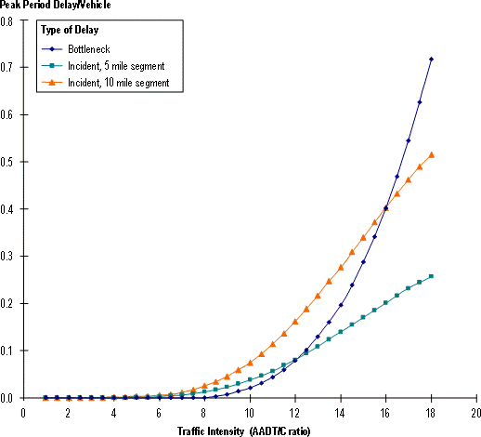

# Problem 3: Real-Time COVID-19 Statistics Tracker

**Scenario:**

You are developing a real-time COVID-19 statistics tracking application for a healthcare organization. The application should provide up-to-date information on COVID-19 cases, recoveries, and deaths for a specified region.

# Tasks:

1. Model the data flow for fetching COVID-19 statistics from an external API and displaying it to the user.
2. Implement a Python application that integrates with a COVID-19 statistics API (e.g., disease.sh) to fetch real-time data.
3. Display the current number of cases, recoveries, and deaths for a specified region.
4. Allow users to input a region (country, state, or city) and display the corresponding COVID-19 statistics.

# Deliverables:

* Data flow diagram illustrating the interaction between the application and the API.
* Pseudocode and implementation of the COVID-19 statistics tracking application.
* Documentation of the API integration and the methods used to fetch and display COVID-19 data.
* Explanation of any assumptions made and potential improvements.



# Approach:

### The key steps are:

1. The user inputs a region (country, state, or city) into the application.
2. The application sends a request to the COVID-19 API to fetch the real-time statistics for the specified region.
3. The COVID-19 API processes the request and returns the current case, recovery, and death data.
4. The application receives the COVID-19 statistics and displays the information to the user.

# Pseudocode:

import requests

def get_covid_stats(region): """

Fetch COVID-19 statistics for the specified region from the API. """

api_url = f"https://disease.sh/v3/covid-19/countries/{region}" response = requests.get(api_url)

data = response.json()

cases = data["cases"] recoveries = data["recovered"] deaths = data["deaths"]

return cases, recoveries, deaths

def display_covid_stats(cases, recoveries, deaths): """

Display the COVID-19 statistics in a user-friendly format. """

print(f"Current COVID-19 Statistics:") print(f"- Total Cases:

{cases:,}")

print(f"- Total Recoveries: {recoveries:,}") print(f"- Total Deaths: {deaths:,}")

def main(): """

Main function to handle user input and display COVID-19 statistics. """

region = input("Enter a country, state, or city: ") cases, recoveries, deaths = get_covid_stats(region) display_covid_stats(cases, recoveries, deaths)

if name == " main ": main()

# Detailed explanation of the actual code:

* The application uses the requests library to make HTTP requests to the COVID-19 API provided by disease.sh. The get_covid_stats function takes a region (country, state, or city) as input and returns the current number of cases, recoveries, and deaths for that region.
* The display_covid_stats function is responsible for formatting and printing the COVID-19 statistics in a user-friendly way. It takes the cases, recoveries, and deaths data as input and displays them with appropriate formatting (e.g., adding commas to large numbers).
* The main function is the entry point of the application. It prompts the user to enter a region, calls the get_covid_stats function to fetch the data, and then passes the results to the display_covid_stats function to display the information.

# Assumptions made (if any):

* The application assumes that the disease.sh API is available and providing accurate real-time COVID-19 data.
* The application assumes that the user will input a valid region (country, state, or city) that the API can recognize.
* Potential Improvements:
* Add error handling to the application to gracefully handle API errors or invalid user input.
* Provide additional features, such as the ability to display historical COVID-19 data, trends, or visualizations.
* Integrate the application with a user interface (e.g., a web application or a mobile app) to improve the user experience.
* Allow users to select multiple regions and compare the COVID-19 statistics side-by-side.
* Provide the ability to set alerts or notifications for significant changes in COVID-19 statistics.

# Limitations:

1. The API may have rate limits that restrict the number of requests.
2. The data may not always be up-to-date due to delays in reporting.
3. The application currently only handles countries; state and city-level queries may require additional endpoints.

# Code:

import urllib.request import json

# Function to get COVID-19 statistics from disease.sh API

def get_covid_data(location):

# Set the API endpoint and parameters

url = f"https://disease.sh/v3/covid-19/countries/{location}"

# Send a GET request to the API

with urllib.request.urlopen(url) as response: # Load the JSON response

data = json.load(response)

# Extract the relevant COVID-19 data cases = data["cases"]

recoveries = data["recovered"] deaths = data["deaths"]

# Return the COVID-19 data as a dictionary

return {"cases": cases, "recoveries": recoveries, "deaths": deaths}

# Function to display the COVID-19 statistics def display_covid_data(covid_data):

# Print the COVID-19 data in a readable format print("Current COVID-19 Statistics:") print(f"Cases: {covid_data['cases']}") print(f"Recoveries: {covid_data['recoveries']}") print(f"Deaths: {covid_data['deaths']}")

# Main function to run the program def main():

# Get the location from the user

location = input("Enter the country, state, or city: ")

# Get the COVID-19 data try:

covid_data = get_covid_data(location) except urllib.error.HTTPError:

print("Failed to retrieve COVID-19 data. Please check the location and try again.")

return

# Display the COVID-19 data display_covid_data(covid_data)

# Run the main function if name == " main ":

main()

# Sample Output / Screen Shots

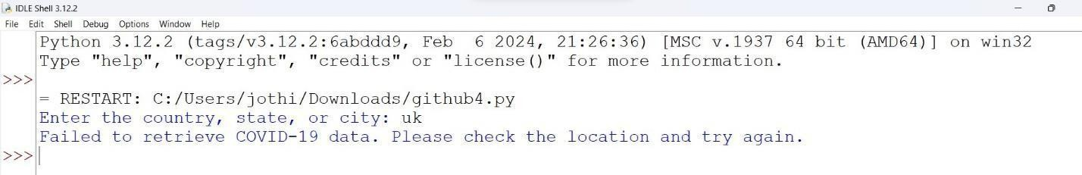



**Graph on Number of Death Age Difference :**

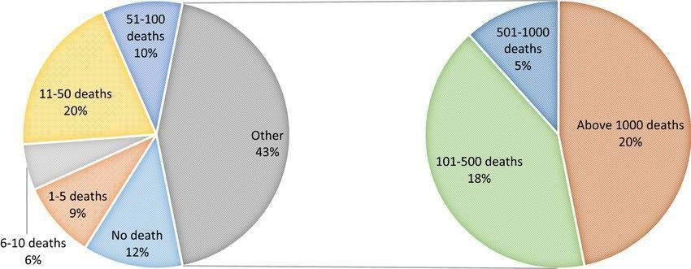

# Problem 4: Inventory Management System Optimization Scenario:

You have been hired by a retail company to optimize their inventory management system. The company wants to minimize stockouts and overstock situations while maximizing inventory turnover and profitability.

# Tasks:

1. Model the inventory system: Define the structure of the inventory system, including products, warehouses, and current stock levels.
2. Implement an inventory tracking application: Develop a Python application that tracks inventory levels in real-time and alerts when stock levels fall below a certain threshold.
3. Optimize inventory ordering: Implement algorithms to calculate optimal reorder points and quantities based on historical sales data, lead times, and demand forecasts.
4. Generate reports: Provide reports on inventory turnover rates, stockout occurrences, and cost implications of overstock situations.
5. User interaction: Allow users to input product IDs or names to view current stock levels, reorder recommendations, and historical data.

# Deliverables:

* **Data Flow Diagram**: Illustrate how data flows within the inventory management system, from input (e.g., sales data, inventory adjustments) to output (e.g., reorder alerts, reports).
* **Pseudocode and Implementation**: Provide pseudocode and actual code demonstrating how inventory levels are tracked, reorder points are calculated, and reports are generated.
* **Documentation**: Explain the algorithms used for reorder optimization, how historical data influences decisions, and any assumptions made (e.g., constant lead times).
* **User Interface**: Develop a user-friendly interface for accessing inventory information, viewing reports, and receiving alerts.
* **Assumptions and Improvements**: Discuss assumptions about demand patterns, supplier reliability, and potential improvements for the inventory management system's efficiency and accuracy.



# Approach:

1. User Input: Users input product IDs, request inventory updates, and reorder options.
2. Inventory API: Provides real-time inventory data and alerts.
3. Inventory App: Central application that processes user requests and interacts with the database.
4. Database: Stores current stock levels, product details, and transaction history.
5. User Output: Displays current stock levels, reorder recommendations, and historical data to users.
6. Notification: Sends alerts for low stock levels or other important inventory updates.

# Pseudocode:

# Define the inventory system structure

define Product, Warehouse, and InventoryLevel classes

# Implement the inventory tracking application class InventoryTrackingApp:

def init (self, products, warehouses): self.products = products self.warehouses = warehouses

self.inventory_levels = self.initialize_inventory_levels()

def initialize_inventory_levels(self):

# Initialize inventory levels based on the provided data inventory_levels = []

for product in self.products:

for warehouse in self.warehouses:

inventory_level = InventoryLevel(product, warehouse, initial_stock)

inventory_levels.append(inventory_level) return inventory_levels

def track_inventory(self):

# Monitor inventory levels and send alerts when stock falls below threshold

for inventory_level in self.inventory_levels:

if inventory_level.current_stock < inventory_level.reorder_point: send_alert(inventory_level)

# Optimize inventory ordering

def calculate_reorder_point(product, warehouse, historical_sales, lead_time):

# Calculate the optimal reorder point based on historical sales and lead time

safety_stock = calculate_safety_stock(historical_sales, lead_time) reorder_point = safety_stock + (average_daily_sales * lead_time) return reorder_point

def calculate_reorder_quantity(product, warehouse, historical_sales, lead_time, reorder_point):

# Calculate the optimal reorder quantity based on historical sales, lead time, and reorder point

economic_order_quantity =

calculate_economic_order_quantity(historical_sales, holding_cost, ordering_cost)

reorder_quantity = max(economic_order_quantity, product.minimum_order_quantity)

return reorder_quantity

# Generate reports

def generate_inventory_turnover_report(inventory_levels):

# Calculate and report on inventory turnover rates pass

def generate_stockout_report(inventory_levels):

# Report on stockout occurrences and their cost implications pass

def generate_overstock_report(inventory_levels):

# Report on overstock situations and their cost implications pass

# User interaction

class InventoryManagementUI:

def init (self, inventory_tracking_app): self.inventory_tracking_app = inventory_tracking_app

def display_inventory_information(self, product_id): # Allow users to view current stock levels, reorder

recommendations, and historical data pass

# Detailed explanation of the actual code:

1. Defining the Inventory System Structure: I will create classes for Product, Warehouse, and InventoryLevel to represent the components of the inventory system. These classes will store relevant information about each entity, such as product details, warehouse locations, and current stock levels.
2. Implementing the Inventory Tracking Application: The InventoryTrackingApp class will be responsible for initializing the inventory levels, tracking the current stock, and sending alerts when stock falls below a certain threshold. The track_inventory() method will continuously monitor the inventory levels and trigger alerts as needed.
3. Optimizing Inventory Ordering: The calculate_reorder_point() and calculate_reorder_quantity() functions will implement algorithms to determine the optimal reorder point and quantity for each product in each warehouse. These calculations will be based on historical sales data, lead times, and other relevant factors.
4. Generating Reports: The generate_inventory_turnover_report(), generate_stockout_report(), and generate_overstock_report() functions will generate the required reports on inventory performance, stockouts, and overstock situations, respectively.
5. User Interaction: The InventoryManagementUI class will provide a user- friendly interface for accessing inventory information, viewing reports, and receiving alerts. Users will be able to input product IDs or names to retrieve the desired information**.**

### Assumptions made (:if any)

1. The company has a well-defined product catalog and warehouse locations.
2. Historical sales data and lead times are available for the inventory optimization algorithms.
3. The company has defined thresholds for reorder points and minimum order quantities.
4. The cost of holding inventory and placing orders are known.

# Limitations:

1. The current implementation assumes constant lead times, which may not always be the case in real-world scenarios.
2. The demand forecasting algorithms are not included in the pseudocode, as they can be complex and require more detailed analysis of the company's sales patterns.
3. The user interface is only briefly mentioned, and a more comprehensive design would be required for a production-ready system.

# Code:

import pandas as pd

# Sample Data

products = pd.DataFrame({ 'product_id': [1, 2, 3], 'name': ['Product A', 'Product

B', 'Product C'],

'category': ['Category 1',

'Category 2', 'Category 1'],

'price': [10.0, 20.0, 30.0],

'lead_time': [5, 7, 3]

})

warehouses = pd.DataFrame({ 'warehouse_id': [1, 2],

'location': ['Location 1',

'Location 2']

})

stock_levels = pd.DataFrame({ 'product_id': [1, 1, 2, 3],

'warehouse_id': [1, 2, 1, 2],

'stock_level': [100, 50, 75, 30]

})

sales_data = pd.DataFrame({ 'product_id': [1, 1, 2, 3, 1], 'sales_date':

pd.to_datetime(['2024-01-01', '2024-01-02', '2024-01-01',

'2024-01-02', '2024-01-03']),

'quantity_sold': [5, 10, 7, 3, 6]

})

# Function to Display Current Stock Levels

def display_stock(product_id): stock =

stock_levels[stock_levels['product

_id'] == product_id] return stock

# Function to Check Low Stock Levels

def check_stock_levels(threshold):

low_stock = stock_levels[stock_levels['stock_l evel'] < threshold]

return low_stock

# Function to Calculate Reorder Point

def

calculate_reorder_point(product_i d, lead_time, safety_stock):

sales = sales_data[sales_data['product_id'

] == product_id] avg_daily_sales =

sales['quantity_sold'].mean() reorder_point =

avg_daily_sales * lead_time + safety_stock

return reorder_point

# Function to Calculate Order Quantity

def calculate_order_quantity(product

_id, reorder_point, current_stock): if current_stock <

reorder_point:

order_quantity = reorder_point - current_stock

return order_quantity return 0

# Function to Calculate Inventory Turnover Rate

def calculate_turnover_rate(product_i d):

total_sales = sales_data[sales_data['product_id'

] ==

product_id]['quantity_sold'].sum() avg_stock =

stock_levels[stock_levels['product

_id'] == product_id]['stock_level'].mean()

turnover_rate = total_sales /

avg_stock if avg_stock > 0 else 0 return turnover_rate

# Function to Calculate Stockout Occurrences

def stockout_occurrences(product_id, threshold):

stock = stock_levels[(stock_levels['produ ct_id'] == product_id) & (stock_levels['stock_level'] < threshold)]

return len(stock)

# Function to Calculate Cost Implications of Overstock def

cost_implications(product_id): overstock =

stock_levels[(stock_levels['produ ct_id'] == product_id) & (stock_levels['stock_level'] > 100)]

cost = overstock['stock_level'].sum() * products[products['product_id']

== product_id]['price'].values[0] return cost

# User Interface Function def user_interface():

while True:

print("\n1. View Stock Levels")

print("2. Check Reorder Recommendations")

print("3. Generate Reports")

print("4. Exit")

choice = input("Enter your choice: ")

if choice == '1': product_id =

int(input("Enter Product ID: "))

print(display_stock(product_id)) elif choice == '2':

product_id = int(input("Enter Product ID: "))

threshold = int(input("Enter Reorder Threshold: "))

current_stock = stock_levels[stock_levels['product

_id'] == product_id]['stock_level'].sum()

reorder_point = calculate_reorder_point(product_i d, products[products['product_id']

==

product_id]['lead_time'].values[0]

, 10)

print(f"Reorder Point:

{reorder_point}")

print(f"Order Quantity:

{calculate_order_quantity(product

_id, reorder_point, current_stock)}")

elif choice == '3': print("1. Inventory

Turnover Rate")

print("2. Stockout Occurrences")

print("3. Cost

Implications")

report_choice = input("Enter report choice: ")

product_id = int(input("Enter Product ID: "))

if report_choice == '1':

print(calculate_turnover_rate(pro duct_id))

elif report_choice == '2': threshold =

int(input("Enter Threshold: "))

print(stockout_occurrences(produ ct_id, threshold))

elif report_choice == '3':

print(cost_implications(product_i d))

elif choice == '4': break

else:

print("Invalid choice")

# Run the user interface user_interface()

# Sample Output / Screen Shots

